STAGE 1 – DESIRED RESULTS
Unit Title: ____The Brain______

Established Goals: Students will understand the importance of the brain and become familiar functions of the brain and the basic structure of the nervous system.

Understandings: Students will understand that…  - The brain has two hemispheres.  - Different parts of the brain perform different functions.  - Neurons are the building blocks of the brain.  - Diet, physical exercise and mental challenges contribute to healthy brain development. | Essential Questions:  - Why is our brain important?  - What functions does the brain control?  - How does the brain control different functions?  - What contributes to healthy brain function?  - How is the human brain similar or different to the brain of other animals?  - How does our brain influence our place in the hierarchy of life on the planet?
Students will know:  - basic vocabulary associated with the brain and the nervous system (hemisphere, neuron, dendrite, axon, nucleus, synapse.)  - how the human brain is similar and different to that of other animals.  - how to promote healthy brain development.  - Activities and substances that are harmful to brain development.  - The importance of the human brain in ensuring individual and species survival. | Students will be able to:  - Compare and contrast the human brain with the brain of other animals.  - Communicate observations and ideas using oral or written language.  - Demonstrate curiousity and a sense of wonder about the world.  - Gather information from a variety of sources.  - Select an effective platform for demonstrating their learning.

STAGE 2 – ASSESSMENT EVIDENCE
Performance Tasks:  - Pipe Cleaner Dendrites  - Brain puzzle  - Create and label a model of the brain  - Create a PowerPoint presentation  - Create a video | Other Evidence:  - Active participation in learning process (engaging in discussions, focused use of independent work time)
Key Criteria:
- Student is able to correctly describe at least 3 functions of the brain.
- Student is able to name at least 3 parts of the brain
- Student is able to describe at least two ways to contribute to brain health.

STAGE 3 – LEARNING PLAN

Summary of Learning Activities:

Pre-Lesson Foundational Background Building Homework:

Teacher introduces unit by presenting a visual of the brain (model, poster)

Teacher assigns brain video to be viewed with family at home prior to initial lesson to take place the following day.
https://www.youtube.com/watch?v=RAMqfq_G4Ms (MagicBox Animation)

Whole Class Lesson #1
- Elbow buddy sharing about video (students share what they learned in the video they previewed at home) (1 min)
- Record what students volunteer they know about the brain on chart paper to display in the room. (2 minutes)
- Demonstrate the size of the brain by putting two fists together
- Direct students to the fact that the different parts of the brain perform different functions. (2 minutes)

Whole Class Lesson Cont’d
- Reinforce learning with construction of individual playdough brains (15-20 minutes)
http://www.science-sparks.com/2014/03/02/make-a-model-brain/
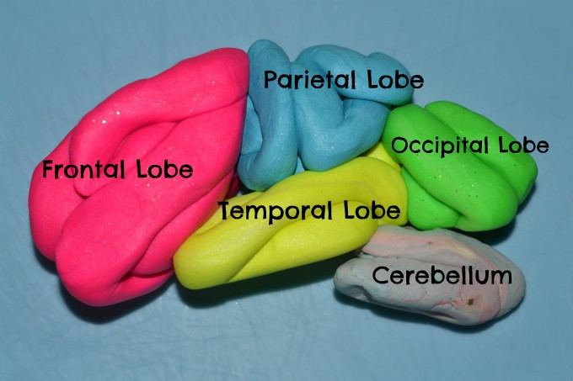

  - You will need several colours of playdough (pink, yellow, blue, green, grey), paper plates toothpicks and labels to label the parts
  - Distribute paper plates and baggies with pre-portioned amounts of playdough.
  - Demonstrate how to make “sausages” to wind into the different parts of the brain
  - Have students wind pink playdough sausage into the frontal lobe on the paper plate. Remind students of the frontal lobe’s function.
  - Have students roll blue playdough into a sausage and wind it into the parietal lobe and place it next to the frontal lobe on the paper plate.
  - Have students roll yellow playdough into a sausage and wind it into the temporal lobe below the parietal lobe.
  - Next students roll the green playdough into a sausage and wind it into the occipital lobe next to the parietal and temporal lobes.
  - Complete the model by creating the cerebellum out of grey playdough and labelling with toothpicks with flags written on by either the teacher or student depending on their ability.
- Conclusion
  - Gather students
  - Review what we learned about the brain today. (2 minutes)
  - Elbow Buddies share one thing they each wonder about the brain with each other. (1 minute)
  - Students are tasked with sharing their “wonder” with their family who will record it on an index card for them as a home-school connection.
  - Conclude by singing ”My Brain is So Very Important” to the tune of “My Bonnie Lies Over the Ocean”
(2 minutes)
  - Blog posting will direct families to videos on how they can make model brains with students at home.
https://www.youtube.com/watch?v=-9Yrhy2lvZY and https://www.youtube.com/watch?v=qR-zyNVsVQA

Whole Class Lesson Two
- Review/Group Challenge (5 minutes)
  - Students are divided into groups and tasked with sticking toothpicks flags into the correct parts of model brains.

- Group instruction (3 minutes)
  - Students are reminded that there are many places to get information.
    - Books
    - Magazines
    - Newspapers
    - Internet
  - Today we are going to focus on the Internet. On the Internet you can find articles, videos and information to contact experts.
  - Display computer desktop on screen with projector.
  - Demonstrate how to get to preselected sites about the brain using links in the shortcut folder.

- Individual exploration (20 minutes)
  - Students logon to computers in the computer lab and visit pre-selected sites to explore the brain

- Conclusion
  - Return to class
  - Share discoveries with elbow buddies
  - Home-school connection is to share one of the websites with a family member and identify what you found most interesting.

Unit continues with students gathering information from books and websites to create a presentation (model, PowerPoint, poster or piece of writing that demonstrates their learning.)

Criteria | Not Yet Meeting Expectations | Meeting Expectations | Exceeding Expectations
Content | Does not include the names and functions of three parts of the human brain.  Does not show a comparison between the human brain and that of at least one other animal.  Does not include statements of how the brain is important.  (5) | Includes the names and functions of three parts of the human brain.  Includes comparison of the human brain to at least one other animal.  Includes statements of how the brain is important.  (15) | Includes the names and functions of more than three parts of the brain.  Comparisons between the human brain and the brains of other animals contain more than three attributes.  Includes statements with supporting data that define the brain’s importance to the survival of humanity.  (20)
Organization | Chosen means of representing understanding does not follow a logical progression. Not cohesive. Difficult to follow.  (2) | There is a basic organization to the presentation. Cohesive.  (3) | The presentation follows a logical progression with effective transitions from one element to another.  (5)
Presentation | Presentation did not demonstrate application of knowledge or skills presented in class.  (5) | Chosen means of representing understanding sufficiently demonstrates application of the knowledge and skills presented in class  (10) | Chosen means of representing understanding in detailed, neat, engaging and sufficiently demonstrates application of the knowledge and skills presented in class.  (15)
Participation | Does not participate in partner or group discussions.  Does not produce evidence of participation in class activities (completed artifacts such as model brain, etc.)  (5) | Contributes to partner and group discussions at least 75% of the time.  Produces artifacts as evidence of participation in class activities (brain model, pipe cleaner dendrite, etc)  (20) | Consistently makes insightful and on topic contributions to partner and group discussions.  Produces detailed, careful artifacts as evidence of participation in class activities (brain model, pipe cleaner dendrite, etc)  (30)

